Instructions on Preparing CAL 2026 Submissions¹

Author(s)

Authors in order: Institution
Institution address
Authors’ e-mail addresses

Abstract
Short and informative abstract.

1 Introduction*

The authors will introduce the topic of their submission.

2 Section title

Another section.
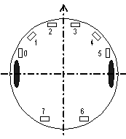

Fig. 1. This is how we insert figures..

3 Section title

This is how we sort text into sections, subsections and subsubsections

3.1 Subsection title

Subsection text.

3.1.1 Subsubsection title

Subsubsection text.

References

Hornik, K., Stinchcombe, M. and White, H. (1989). Multilayer feedforward networks are universal approximators. Neural Networks, 2(5):359–366.

Russell, S. and Norvig, P. (2003). Artificial Intelligence:
A Modern Approach. Prentice-Hall, 2. ed.

This is how we write footnotes.

